Environmental Systems – Dynamic Systems, Simulation and Modelling

A. Schupp, J. Schwalb & Schönberg, A.

**1. Introduction**

The goal of this work is to simulate a biological invasion of a superior species in a stable ecosystem. Ecosystems are complex, dynamical, non-linear and multilevel system with many feedbacks due to the co-operation of positive and negative loops (Awrejcewicz et al 2015, p.267). An appropriate way to model and analyse the dynamics of ecosystems is the method of “Dynamic Systems” which was developed by Jay W. Forrester in the late 1950's (Awrejcewicz et al 2015, p.267). The open access Software VENSIM (Venata Systems Inc 2015: VENSIM) will be used to simulate a predator pray system with two predators in a food competition.

**2. Model scenario „Invasive Species“**

Since the increasing transport and exchange caused by globalisation (Perrings et al. 2005, p.212) ecosystems are increasingly threatened by invasive species (Meyerson & Mooney 2007, p. 199). If a foreign species reaches a new ecosystem there is a chance that it can establish in the new habitat. A successful reproduction can lead to an invasion of the native ecosystem with a probable risk of displacement to native species. (Nentwig 2010, p.16ff). An actual example is *harmonia axyridis* (Asian Ladybug) which was introduced in many countries as a biological control agent (Majerus et al. 2006, p.210f., after Gordon 1985) but has negative influences on the native Ladybug (*Coccinellidae*) populations. *H. axyridis* has some superiorities over native species like a higher reproduction rate and a fast dispersion (Majerus et al. 2006, p.210). The model simulates the arrival of *h. axyridis* as a superior predator in a stable system with native *Coccinellidae* as native predator feeding on *sternorrhyncha* (aphids) as prey. We assume that the superior *h. Axyridis* will outcompete the native species due to its advantages.

**3. Model capability**

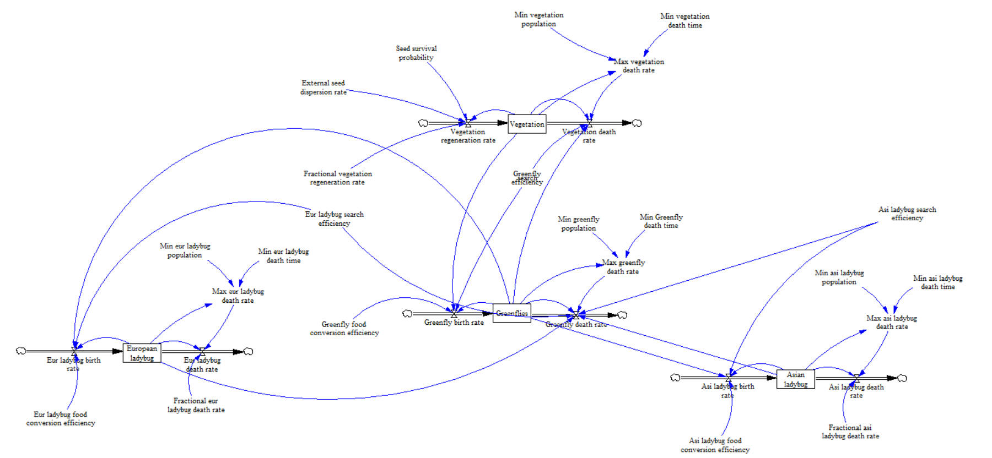The model is based on the Lotka-Volterra predator prey model (Venkat 2005, p.2) with a second predator as the invasive species (see fig. 1). The model is capable of simulating the food competition between both predators feeding on the same prey. The prey birth-rate is dependend on the amount of food provided by the vegetation which regrows constantly. The predators birth-rates are dependent on the search efficiency on prey and the food conversion efficiency-rate.

Fig.1: Predator-prey model: Greenfly (prey) feeding on vegetation, European Ladybug (predator), Asian Ladybug (invasive species).

Both predators have a constant death-rates but cannot be extinguished by setting a minimum population size. The prey death-rate is dependent on the search efficiency of both predators and has a maximum death-rate to ensure survival. The Vegetation regrows constantly and is used as a limit for prey population. The main adjustment to simulate the superiority of the Asian Ladybugis an increased food conversion efficiency (simulates a higher predation efficiency). For the Initial Values we used (in biomass) 1000 vegetation, 100 aphids (Greenflies) and 10 European Ladybugs for a numerical relationship in ecosystems food chain and 1 Asian Ladybug to simulate the arrival of a small invasive population.

**4. Results**

With equal reproduction-rates the ecosystem is in a stable condition (see fig. 2). Increasing the reproduction-rate of the Asian Ladybug by 10% leads to an increasing amount of individuals while the native species decreases due to limited food supply (see fig.3). After approximately 500 days the Asian Ladybug outcompetes the European Ladybug and reaches the origin population size of the European Ladybug (see fig. 4). Since the European Ladybug is extinguished the ecosystem reaches an equilibrium (see fig.5).

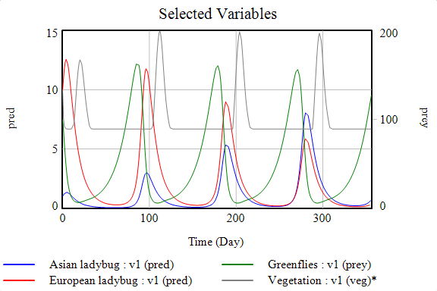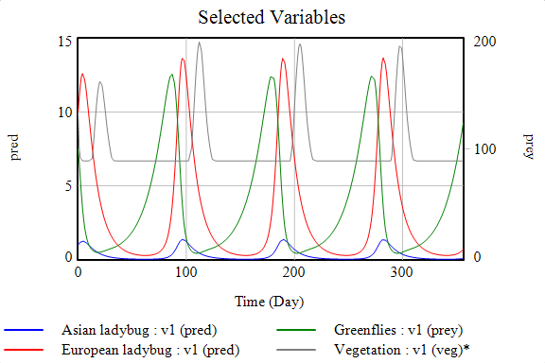

Fig. 2: Equal reproduction rate of both predators Fig. 3: Increased reproduction rate for Asian Ladybug (10%)

for a timescale of 365 days. for a timescale of 365 days.

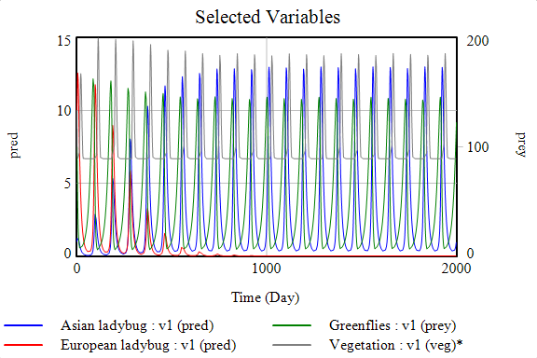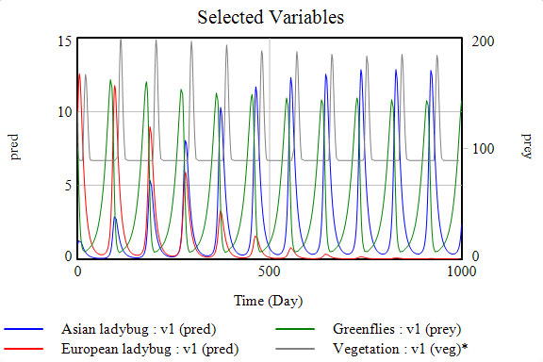

Fig. 4: Extinction of the European Ladybug Fig. 5: Recover of ecosystem stability .

**5. Discussion**

The model shows that if a predator with superior abilities arrives in a stable ecosystem it outcompetes the native predator due to the higher reproduction-rate and the system reaches an equilibrium after extinction of the native predator. In reality the system is more complex which was not implemented in this simple model. For example *h. Axyridis* carries a parasite which damages native Ladybug species while itself is resistant (Everts 2013, p. 44) and further has improved overwintering abilities (Labrie 2008, p.860f). Additionally the initial values were selected to show the food competition but do not represent actual representative values. The model gives an idea of the major effect of superior reproduction rate in a food competition scenario.

**6. Literature**

Awrejcewicz, J., Kazmierczak, M., Mrozowski, J. & P. Olejnik (2015): Dynamical Systems – Mathematical and Numerical Approaches.

Everts, S. (2013): Invading Ladybugs Carry Bioweapons. In: Chemical & Engineering News. Volume 91. Issue 21. 44-45.

Majerus M., Strawson, V. & H. Roy (2006): The potential impacts of the arrival of the Harlequin ladybird, Harmonia axyridis (Pallas) (Coleoptera: Coccinellidae), Britain. Ecol Ent 31,  207– 215.

Meyerson, L.A. & Mooney, H.A.MEYERSON (2007): Invasive alien species in an era of globalization. Frontiers in Ecology and the Environment, 5, 199–208.

Nentwig, N. (2010): Invasive Arten. Göttingen.

Labrie, G. Coderre, D. & E. Lucas (2008): Overwintering Strategy of multicolored Asian Lady Beetle (Coleoptera: Coccinellidae): Cold-Free Space As a Factor of Invasvie Success. In. Ann. Entomol. Soc. Am. 101(5): p. 860-866.

Perrings, C., Dehnen-Schmutz, K., Touza, J. & M. Williamson (2005): How to manage biological invasions under globalization. Trends in Ecology & Evolution, 20, 212–215.

Venkat, K. (2005): Predator-Prey Dynamics and Wildfile Management: A System Dynamics Model.